L1F26BSCS0313
Muazzam Munir

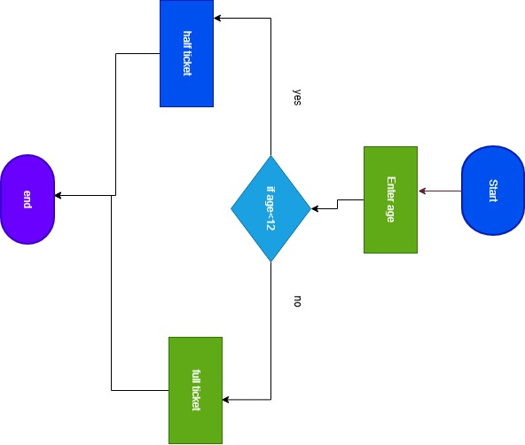

Age | condition | Ticket printout
8 | false | Half ticket
12 | true | Full ticket
30 | true | Full ticket

